DNS Firewall

🔥 What is a DNS Firewall?
# Source: AI Source: Provided by: [Data Path: Persons Table -> ID Column: 1, Name_En Column: Motasem Essam] -> From: [ChatGPT] on [1/18/2026]
A DNS Firewall is a network security system that monitors and filters DNS traffic to protect users from malicious domains, block threats like malware or phishing, and control internet access.
It acts like a protective layer at the DNS level, blocking dangerous or unwanted domains before a connection is made.

🧠 Simple Explanation:
# Source: AI Source: Provided by: [Data Path: Persons Table -> ID Column: 1, Name_En Column: Motasem Essam] -> From: [ChatGPT] on [1/18/2026]
When you try to visit a website:
- A normal DNS just resolves the domain.
- A DNS Firewall checks if that domain is safe.
  - ✅ If it's clean → it resolves the IP as usual.
  - ❌ If it's malicious/blocked → it blocks or redirects the request.

⚙️ How It Works
# Source: AI Source: Provided by: [Data Path: Persons Table -> ID Column: 1, Name_En Column: Motasem Essam] -> From: [ChatGPT] on [1/18/2026]
- User tries to access a domain (e.g., badsite.com)
- DNS query is sent to the DNS firewall
- The firewall checks the domain against a blocklist
- If it matches:
  - It blocks the request
  - Or redirects to a warning or safe page
- If safe, it resolves normally

🛡️ What It Protects Against
# Source: AI Source: Provided by: [Data Path: Persons Table -> ID Column: 1, Name_En Column: Motasem Essam] -> From: [ChatGPT] on [1/18/2026]
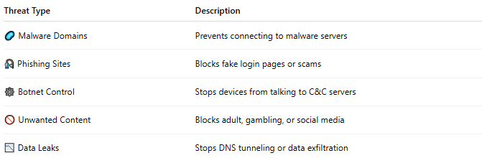

Threat Type | Description
🦠 Malware Domains | Prevents connecting to malware servers
🎣 Phishing Sites | Blocks fake login pages or scams
🕸 Botnet Control | Stops devices from talking to C&C servers
🚫 Unwanted Content | Blocks adult, gambling, or social media
📉 Data Leaks | Stops DNS tunneling or data exfiltration

🧩 DNS Firewall vs DNS Filtering
# Source: AI Source: Provided by: [Data Path: Persons Table -> ID Column: 1, Name_En Column: Motasem Essam] -> From: [ChatGPT] on [1/18/2026]
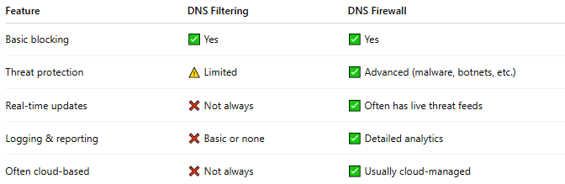

]
Feature | DNS Filtering | DNS Firewall
Basic blocking | ✅ Yes | ✅ Yes
Threat protection | ⚠️ Limited | ✅ Advanced (malware, botnets, etc.)
Real-time updates | ❌ Not always | ✅ Often has live threat feeds
Logging & reporting | ❌ Basic or none | ✅ Detailed analytics
Often cloud-based | ❌ Not always | ✅ Usually cloud-managed

🧱 Examples of DNS Firewall Providers
# Source: AI Source: Provided by: [Data Path: Persons Table -> ID Column: 1, Name_En Column: Motasem Essam] -> From: [ChatGPT] on [1/18/2026]
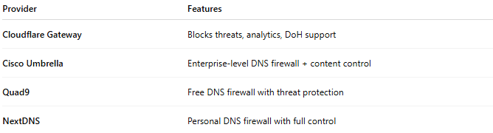

Provider | Features
Cloudflare Gateway | Blocks threats, analytics, DoH support
Cisco Umbrella | Enterprise-level DNS firewall + content control
Quad9 | Free DNS firewall with threat protection
NextDNS | Personal DNS firewall with full control

✅ Summary
# Source: AI Source: Provided by: [Data Path: Persons Table -> ID Column: 1, Name_En Column: Motasem Essam] -> From: [ChatGPT] on [1/18/2026]
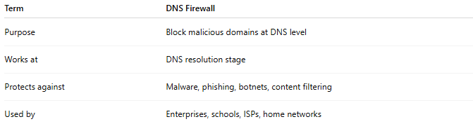
Term | DNS Firewall
Purpose | Block malicious domains at DNS level
Works at | DNS resolution stage
Protects against | Malware, phishing, botnets, content filtering
Used by | Enterprises, schools, ISPs, home networks

